A1 Mini Team Assignment: Explorations in Visualizations

**Visualization Chosen**: Codebases: Millions of lines of code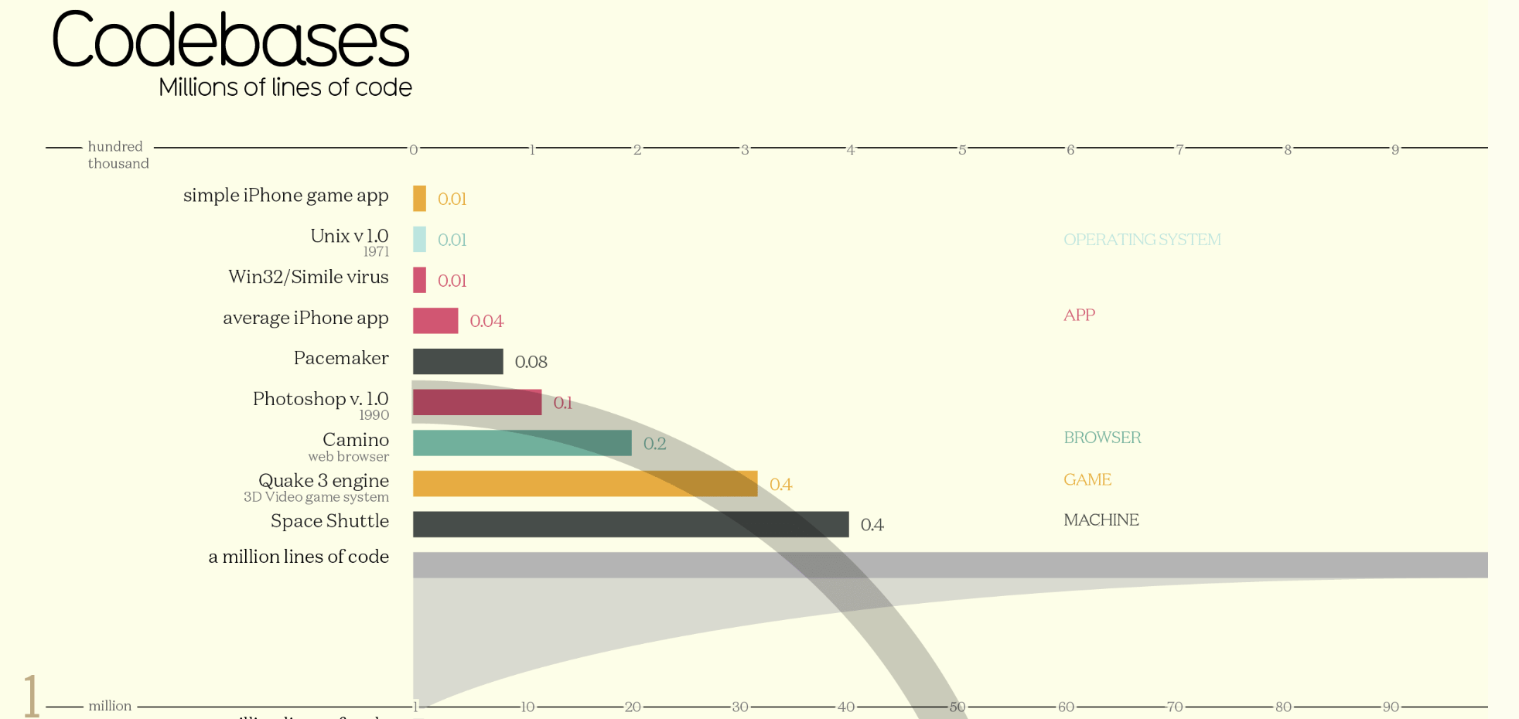

**Reference:** <https://informationisbeautiful.net/visualizations/million-lines-of-code/>

**Main Takeaway**: Comparison in the number of lines of code needed to program different technological and biological objects

**Purpose:** The purpose of this visualization is to rank the number of lines of different computer programs’ source codes, show the growth throughout their respective updates and compare them to the lines of code in the DNA of some biological creatures

**Content:** In this visualization, we can see the difference between different technologies throughout the years with their total lines of code used. The different vertical lines represent the number (in millions) of lines of code used to develop the software or platform presented in the visualization. The raw data in this visualization include the following: object, number of lines of code (millions) and type of object (operating system, app, browser, game, machine and organism). As far as processed data, we are also shown the percentage growth in the number of lines of each of the programs’ updates.

**Structure:** The raw data and the processed data were represented in two different ways**.** The raw data, the one with the most emphasis, is visualized in the form of a bar graph in which the length of each bar represents the number of lines of code and the color of the bar serves as the distinction between different types of objects. The processed data is represented in arc-like structures that connect each of the computer programs to their updates and in which the thickness of the arc represent the growth in number of lines.

**Formatting:** For a better reading, the visualization is divided into several ranges of lines of code. Colors are used to segment into different categories, for example:

* Yellow is used for games
* Pink is used for apps
* Green for browsers

Also, the fact that is sorted in an ascending order makes it easier to read and visualize the difference in complexity between each of the objects represented.